Use of Agrochemicals in Pineapple Farming: A case study from Madhupur Forest Areas of Bangladesh
M. Ashraful Alam¹, M Asaduzzaman Sarker^{2*}, M. Jiaul Hoque² and M Shariful Hasan Khan¹

ABSTRACT
Non-optimal and non-judicious use of agrochemicals has increased particularly in developing countries with introduction of modern agriculture. This may lead to environmental degradation and health hazards to both growers and consumers. Thus, a case study was conducted at Jalchatra village of Madhupur upazila (sub-district), Bangladesh to determine the extent of use of agro-chemicals by the pineapple farmers. Data were collected from randomly selected 60 pineapple farmers out of 300 farmers of the study village during September to October 2017 through questionnaire survey. Majority (62%) of the respondents hid high extent of use of agro-chemicals, where 38% of them had medium extent of use of agro-chemicals during pineapple farming. Agro-chemicals like urea, TSP, MoP, superfix, gibberellic acid, calcium carbide and formalin were being extensively applied on pineapple for growing pineapple as well as for artificial ripening and enhancing the fruit size of the pineapple. From the correlation analysis it was evident that age, farming experience, extension media contact, training on agro-chemicals use and knowledge on harmful effects of agro-chemicals had significant relationships with their extent of use of agro-chemicals in pineapple farming. The study also explored that more than 90% of the respondent farmers had used higher doses and higher frequencies of agro-chemicals in pineapple farming.
Keywords: Agrochemicals, Pineapple Farming, Madhupur, Bangladesh

INTRODUCTION
Pineapple (Ananascomosus) is a worldwide popular fruit because of its pleasant flavor, delicious taste, high nutritional and medicinal values (Sabahelkhier et al., 2010).Pineapple as a fruit in Bangladesh ranks 3rd position next to mango and banana based on its production (BBS, 2018).
Pineapple is as flesh and its juice. Varieties Giant Kew, Honey Queen and red Spanish (Ghorashal) are popularly grown in Bangladesh, mostly in terrace and hilly areas (Tangail, Sylhet, Chittagong, Comilla districts and Chittagong Hill Tracts). About 45,685 ha of land are now under pineapple cultivation with total production of 0.23 million MT (Proshad et al., 2018). In Bangladesh, the harvesting period of pineapple is June to August (monsoon season). Lack of storage, processing and marketing facilities is a big limitation of expansion of pineapple cultivation. The growers do not get a good price during the season (Hassan and Islam, 2017).
The use of agrochemicals has increased with introduction of modern agriculture (Joy and Sindhu, 2012). Unfortunately, the farmers are not adequately aware of the harmful effects of agro-chemicals. They use chemicals as advised by the agro-chemical dealers. It is reported that at least 10 types of chemicals and insecticides are used from the time of planting until harvest of fruits. They also use special type of chemicals for artificial ripening and delayed decay purposes. This practice is evidenced in pineapple farming at Madhupur of Tangail district and it is a very serious issue in the context of food safety and people’s health for its consumption (Mursalat et al., 2013). Non-optimal and non-judicious use of agrochemicals (which are toxic in nature or toxic when used at high concentration) may result in environment degradation and health hazards to both growers and consumers (Proshad et al., 2018). Many scientists have reported that weakness, dizziness, skin ulcer and heart related diseases might be caused due to regular consumption of artificially ripened pineapples (Jayan, 2012; Rahim, 2012). Thus, the present study was undertaken to assess the extent of agrochemicals use by the pineapple farmers in Madhupur area of Bangladesh.

MATERIALS AND METHODS
Study location
The case study was done at Jalchatra village of Madhupur upazila (sub-district) under Tangail district. Pineapple is extensively grown in this area. Madhupur is located at 24.6167° North 90.0250° East. It has 74,984 units of households having 0.297 million people in the total area of 500.67 km². It has a large forest area named 'Madhupur Sal Forest". Total cultivable land is 32900 hectares, of which the fallow land is 2000 hectares (BBS, 2018). About 65% area has irrigation facilities.
Farmers of Madhupur upazila grow a variety of crops, the major crops being rice, jute, cotton, potato, pointed gourd, ginger, cassava, vegetables, pineapple, banana, jackfruit, litchi and papaya. About 70% of the country’s pineapple cultivation is in Madhupur area.
Madhupur is traditionally an agrarian sub-district like other sub-districts of Bangladesh. Farmers of Madhupur grow variety of crops. The major crops grown in Madhupur are paddy rice, jute, wheat, cotton, potato, pointed gourd, ginger, betel leaf, cassava, vegetables, mango, jackfruit, litchi, papaya, pineapple and olive. However, Madhupur is famous for pineapple cultivation in Bangladesh. About 70% of the country’s pineapple grows in Madhupur area of Bangladesh.

Sampling, Data Collection and Analysis
The sample size should be as large as possible to allow for adequate degrees of freedom in the statistical analysis. In other words, administration of field research, processing and analyzing of data should be manageable within the limits imposed by physical, human and financial resources. A reasonable size of sample to achieve the objectives of the study was taken into account. Simple random sampling technique was followed in this study. Thus, a total of 60 pineapple farmers were selected from a total of 300 pineapple farmers.
For collecting primary data through survey method, preparation of interview schedule is, of course, crucial need. A set of relevant questions were set in the interview schedules for having reliable information from the pineapple farmers. Then the draft schedule was pretested and attention was paid for inclusion of new information which was not included in the draft schedule. Thus, the draft schedule was improved, rearranged and modified in the light of the actual and practical experiences gathered from pre-testing. After making necessary adjustment, a final interview schedule was developed following logical sequences. The empirical data for the study were collected during September to October, 2017.
The researcher made all possible efforts to establish desired rapport with the respondents, so that they could feel free to respond to the questions contained in the schedule. During the interview, the researcher explained the purpose of collecting data to the respondent and did not face any difficulty to establish rapport in collecting data.
To measure the use of agrochemicals in pineapple farming a 4-point rating scale was used. A total of 14 agro-chemicals were included into the questionnaire and asked to the respondents to give their responses regarding their use following a 4-point rating scale. These selected agro-chemicals were categorized into 5 categories like fertilizers, pesticides, hormones, ripening agents and shelf-life enhancer. The score was assigned to each of the responses of the farmers as 3, 2, 1 and 0 respectively. Finally, summation of the score of all of the 14 agro-chemicals was treated as the score of a respondent on use of agro-chemicals in pineapple farming. The collected data were compiled, tabulated, and analyzed in accordance with the objectives of the study. Co-efficient of correlation analysis was employed for exploring relationships between extent of use of agrochemicals by the pineapple farmers and their selected characteristics. For rejecting/accepting any null hypothesis 5% level of significance was used. The Statistical Package for Social Science (SPSS v.16) was used to perform the data analysis.

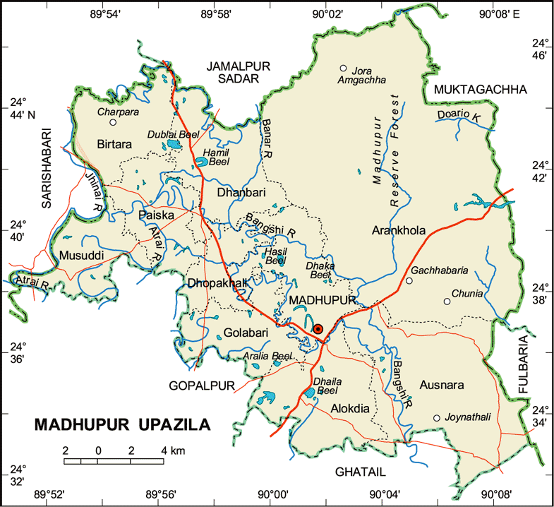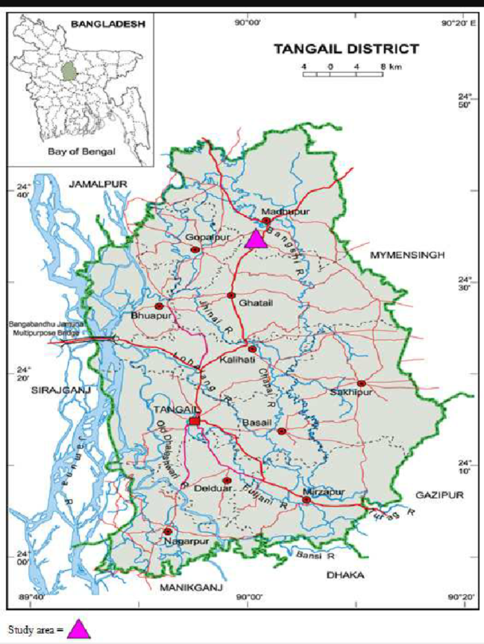
Jalchatra
Figure 1: Map of Tangail district and MadhupurUpazila showing the study area

RESULTS
Socio-economic Characteristics of the Pineapple Farmers
The study took an attempt to analyze the socio-economic profile of the pineapple farmers who were selected for this study. Ten characteristics of the farmers such as: age, educational qualification, family size, farming experience, farm size, annual family income, extension media contact, organizational participation, training on agro-chemicals use and knowledge on harmful effects of agro-chemicals constituted independent variables of the study. Descriptive features of the socio-economic characteristics of the farmers have been shown in Table 1.
Data presented in Table 1 shows that the age of the respondents ranged from 34-56 years, with an average of 45.71 years and standard deviation 7.59. The findings indicate that major portion (83.3%) of the respondents were young to medium aged. Time of age is useful in involving in productive purposes. Data presented in Table 1 shows that educational qualification of the respondent pineapple farmers ranged from 0-8, with an average of 3.90 years and standard deviation 2.85.

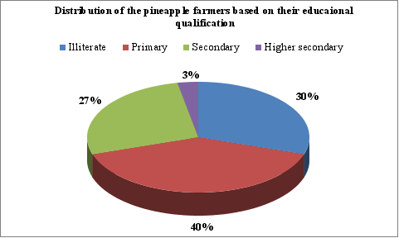
Figure 2: Distribution of the farmers based on their educational qualification

Table 1: Salient characteristics of the respondents (n=60)

Characteristics | Scoring system | Possible Range | Observed Range | Mean | SD
Age | Years | Unknown | 34-56 | 45.7 | 7.59
Educational qualification | Years of schooling | Unknown | 0-8 | 3.90 | 2.85
Family size | No. of members | Unknown | 3-6 | 4.15 | 0.91
Farming experience | Years | Unknown | 12-39 | 24.9 | 10.30
Farm Size | Scale score | 0-24 | 1.12-5.63 | 3.10 | 1.21
Annual family income | ‘000’ BDT | Unknown | 235-402 | 324 | 0.47
Extension media contact | Scale score | 0-24 | 9-15 | 11.8 | 1.52
Organizational participation | Years | 0-9 | 4-7 | 5.43 | 1.31
Training on agro-chemicals use | Days | Unknown | 0-8 | 5.28 | 2.46
Knowledge on harmful effects of agro-chemicals | Scale score | 0-18 | 3-8 | 6.93 | 1.09
* SD= Standard Deviation; * BDT= Bangladeshi Taka

Figure 2 exhibits, the highest proportion of the respondents (40%) had primary education. It is also demonstrated in Figure 2 that a significant portion (30%) of them was illiterate while only 3% of them had higher secondary education and around a quarter (25%) of them had secondary education. Family size of the respondents ranged from 3-6, with an average of 4.15 and standard deviation 0.91. However, the average household size of the study area is a bit smaller than the national average of 4.89 (BBS, 2016). On the other hand, farming experience of the farmers ranged from 12-39 years, with an average of 24.90 years and standard deviation 10.30.
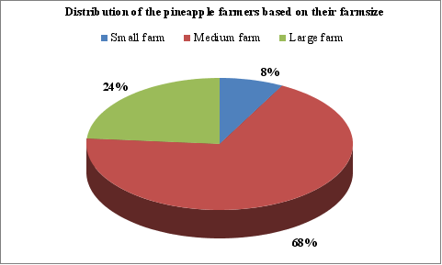
Figure 3: Distribution of the respondents based on farm size
The findings of the study noticed that the farm size of the pineapple farmers ranged between1.12-5.63 ha, with an average of 3.10 ha and standard deviation 1.21. This means the average farm size of the pineapple farmers is much higher than the national average of 0.7ha (BBS, 2013).
Figure 3 demonstrates that the highest proportion of the respondents (68%) had medium farm size, where around a quarter (24.5%) of them had large farm and rest 8% of them had small farm size. However, this finding differs significantly with the national farm size categories of farmers (DAE, 1996).
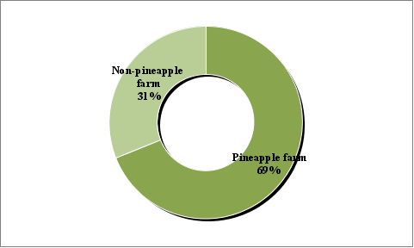
Figure 4: Land allocation for pineapple farming

It is also clearly demonstrates in Figure 4 that 69% of the farm holding of the pineapple farmers were allocated for pineapple farming while the rest 31% were allocated for other crops.
Annual family income of the respondents were ranged between BDT 235-402 (000’) [BDT: Bangladeshi currency; Approx. 80 BDT=1US$], with an average of 323.88 and standard deviation 0.47. Due to better farm gate price of pineapple price and allocation of more than half of the farm land for pineapple farming the average family income of the pineapple farmers were better than ordinary farmers.
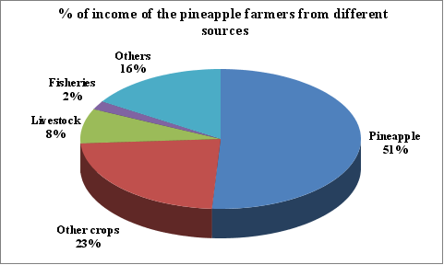
Figure 5: Income of the pineapple farmers from various sources

The findings of the study also showed (Figure 5) the pineapple farmers earned more than half (51%) of their family income from pineapple farming. Where, other crops contributed 23% in their household income. However, the contribution of livestock and fisheries in the family income of the respondent farmers were below 10%. The information of Table 1 indicates that the extension media contact of the respondents ranged from 9-15 against a possible range of 0-24, with an average of 11.80 and standard deviation 1.52. This is also evident from Table 1 that the organizational participation scores of the respondents ranged from 4-7 years with an average of 5.43 and standard deviation 1.31. While the training score on agro-chemicals of the respondents ranged from 0-8 days with an average of 5.28 and standard deviation 2.46. The highest proportion of the respondents (72%) had short training exposure on use of agro-chemicals where 2% of them had medium duration training and rest 26% had no training exposure on use of agro-chemicals.
The score of Knowledge on harmful effects of agro-chemicals of the respondents ranged between 3-8 against a possible range of 0-18, with an average of 6.93 and standard deviation 1.09. Two-thirds (66.7%) of the respondents had average knowledge on harmful effects of agrochemicals use, and one-third (33.3%) of them had poor knowledge. The respondent farmers had good knowledge about harmful effects of use of agro-chemicals in farming. Thus, it is clear that all the respondents of the study area had poor to average knowledge on harmful effects of agro-chemicals use.

Extent of Use of Agro-chemicals in Pineapple Cultivation
The main focus of the study was to assess the extent of use of agro-chemicals by the farmers in pineapple cultivation. Extent of use of agro-chemicals use in pineapple cultivation score of the respondents ranged from 21-25 against a possible range of 0-42, with an average of 22.67 and standard deviation 1.46. Based on their scores, the respondents were classified into four categories i.e. no use, low, medium and high (shown in Table 2).
Table 2: Extent of agro-chemicals use in pineapple farming
Categories | No. | % | Mean | SD
No Use (0) | 0 | 0 | 22.7 | 1.46
Low (1-14) | 0 | 0 | 22.7 | 1.46
Medium (15-28) | 23 | 38.3 | 22.7 | 1.46
High (above 28) | 37 | 61.7 | 22.7 | 1.46
Source: Authors’ survey, 2017

The highest proportion of the respondents (61.7%) had high extent of use of agrochemicals, while 38.3% of them belonged to medium users and none was found in no or low use categories.

Agrochemicals use index (AUI) of the pineapple farmers
For getting a clear picture of using an individual agro-chemical by the respondent pineapple farmers an index was developed and used accordingly. The findings of agro-chemicals use index of the respondent farmers are shown in Table 3.
Varieties of agro-chemicals are used in pineapple farming from planting to plucking of fruits even after plucking to maintain its long shelf-life. However through consultation with the local agro-chemicals dealer 14 chemicals were indentified those are used by the farmers in pineapple farming. It is demonstrated in Table 3 that 90% of the respondents had used higher doses of urea fertilizers and rest 10% of them used recommended doses. However, in the cases of TSP and MoP fertilizers the scenario is quite opposite. It is evident from the Table 3 that 58-82% of them had used recommended doses of TSP and MoP fertilizers and rest of them used lower doses. On the contrary, about half of them had never used the fertilizers like Gypsum, Zinc, Sulfur and Boron. However, the rest 50% of the respondent had used lower doses of the fertilizers like Gypsum, Zinc and Sulphur.
Pineapples are infested by a number of insect pests such as bugs, scale insects, thrips, fruit borer, fruit flies, white grubs, beetles, termites and mites (Joy et al., 2012). To protect pineapple crops from these sorts of insect pests the respondents used organophosphate and carbaryl group of pesticides.
Data presented in Table 3 shows that 30-45% of the respondent farmers had used higher doses of pesticides, whereas about few of them had used recommended doses of pesticides for controlling insect pests in pineapple farming. On the other hand 20-28% of the farmers used lower doses of pesticides. This findings supported by Hossain et al., 2003 and Sarker and Itohara, 2008. The results of the study also shows that more than half (52-67%) of the respondent pineapple growers used higher doses of hormones like Seprfix and Gibberellic acid. However, half (50%) of the respondents used recommended doses of Etheophen hormone. Alike hormones during using ripening agents, majority (45-67%) of them had used higher doses of ripening agents like calcium carbide and ethylene. While one-third to half (33-48%) of the respondents had used recommended doses of ripening agent. On the other hand more than one-third (38%) of the respondent have used higher doses of formalin to enhance shelf-life of their harvested fruits. This finding is supported by Proshad et al., 2018; Sarker and Itohara, 2008 and Sarker et al, 2002.

Table 3: Specific agrochemicals used by the pineapple farmers (n=60)

Agro-chemicals | Pineapple farmers (n=60) |  |  |  |  |  | Agro-chemicals Use Index
Agro-chemicals | High | Recommended | Low |  | Not at all
Fertilizers
Urea | 54 (90) | 6 (10) |  | 0 (0) |  | 0(0) |  | 170
TSP | 0 (0) | 49 (82) |  | 11 (18) |  | 0(0) |  | 109
MoP | 0 (0) | 35 (58) |  | 25 (42) |  | 0(0) |  | 95
Gypsum | 0 (0) | 0 (0) |  | 32(53) |  | 28(47) |  | 32
Zinc | 0 (0) | 0 (0) |  | 29(48) |  | 31(52) |  | 29
Sulphur | 0 (0) | 0 (0) |  | 28(47) |  | 32(53) |  | 28
Pesticides
Diazinon/Dimethoate(Organophosphate) | 18 (30) | 25 (42) |  | 17(28) |  | 0 (0) |  | 121
Sevin (Carbaryl) | 27 (45) | 21(35) |  | 12(20) |  | 0 (0) |  | 135
Hormones
Gibberellic Acid | 31 (52) | 11 (18) |  | 18 (30) |  | 0(0) |  | 133
Superfix (Alpha Napthleneacetic acid) | 40 (67) | 14 (23) |  | 6(10) |  | 0(0) |  | 166
Etheophen | 0 (0) | 30 (50) |  | 24(40) |  | 6 (10) |  | 84
Ripening agents
Calcium carbide | 40 (67) | 20 (33) |  | 0 (0) |  | 0 (0) |  | 160
Ethylene | 27 (45) | 29 (48) |  | 4(7) |  | 0 (0) |  | 143
Shelf-life enhancer
Formalin (Formaldehyde) | 23 (38) | 25 (42) |  | 8(13) |  | 4(7) |  | 127

Source: Authors’ survey, 2017

Figure 6 demonstrates that amongst the agro-chemicals Urea fertilizer ranked 1st position based on its AUI score. However, among TSP and MoP ranked 2nd and 3rd position respectively, while B ranked last position among the fertilizers used. On the other hand amongst all agro-chemicals, hormone Suprfix ranked 2nd position and ripening agent calcium carbide ranked 3rd position respectively. Next to calcium carbide, ethylene, sevin, gibberellic acid and formalin ranked 4th, 5th, 6th and 7th position respectively. It is also evident from Figure 8 that next to fertilizers, hormones and ripening agents are widely used agro-chemicals in pineapple farming in Bangladesh.

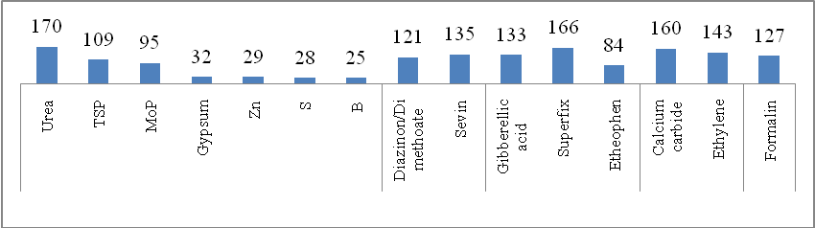
Figure 6: Rank order of the agro-chemicals based on their use index

Relationship between Selected Characteristics of the Pineapple Farmers and Their Extent of Use of Agro-chemicals
This section deals with the findings exploring the relationships between the explanatory and focus variables of the study. The explanatory variables were age, educational qualification, family size, farm size, farming experience, annual family income, extension media contact, organizational participation, training exposure on agro-chemicals use and knowledge on harmful effects of agro-chemicals. The focus variable was “extent of use of agro-chemicals in pineapple cultivation”. The results of correlation of co-efficient between the explanatory and focus variables have been shown in Table 4.
It is evident from Table 4 that among the ten explanatory variables five shows significant relationship with their extent of use of agro-chemicals in pineapple cultivation. Out of five significant variables two of them (i.e., age and farming experience) showed positive relationships with the extent of use of agro-chemicals and three variables (i.e., extension media contact, training on use of agro-chemicals and knowledge on harmful effects of use of agro-chemicals) showed negative relationships.
Table 4: Correlation co-efficient between explanatory and focus variables (n= 60)

Explanatory variables | Correlation co-efficient (r) values with n-2 df
Age | 0.716**
Educational qualification | 0.1
Family size | 0.109
Farming experience | 0.704**
Farm size | 0.052
Annual family income | 0.092
Extension media contact | -0.331**
Organizational participation | 0.107
Training on agro-chemicals use | -0.692**
Knowledge on harmful effects of agro-chemicals | -0.493**
Degrees of freedom (df) = 58
* = Significant at 5% level;
** = Significant at 1% level

DISCUSSION
The majority of the pineapple farmers in the study area used higher doses and higher frequencies of agro-chemicals in pineapple farming. Among them the use of urea fertilizers, hormones, ripening agents and shelf-life enhancer are extremely higher compared to other agro-chemicals. This is may be due to lack of poor knowledge of the pineapple growers on harmful effects of agro-chemicals use and limited access to training on agro-chemicals use. On the other hand, supreme majority (93.3%) of the pineapple farmers had higher income. For this reason they were never hesitate to buy agro-chemicals as recommended by the agro-chemical dealers. It can be mentioned here that the majority portion (51%) of their family income comes from pineapple farming and they have a mindset that more agro-chemicals use can ensure their higher production and subsequently better income from pineapple farming, Farmers’ access to extension services is also low. Due to limited number of extension workers in the mainstream extension organizations, most of the farmers depend on agro-chemical dealers about various aspects of agro-chemicals use. However, the agro-chemical dealers do not have sufficient education and proper knowledge on agro-chemicals, thus mostly they mislead the farmers and push varieties of chemicals even if it is not for the pineapple farmers.
The influential factors associated with pineapple famers’ extent of use of agro-chemicals were age, farming experiences, access to extension services, training on agro-chemicals use and their knowledge on harmful effects of agro-chemicals use. Among the significant variables, age and farming experience of the pineapple farmers showed negative relationship with their extent of use of agro-chemicals. This is due to the reason that the old farmers are not cautious about the negative effects of agro-chemicals on environment as well as human health. Thus, they have used higher amount of agro-chemicals in non-judicious manner. This finding is supported by Sarker and Itohara 2008a. It is very usual that farmers having long farming experience are old by age and they are not aware about the harmful effects of agro-chemicals use in crop production thus their extent of use agro-chemicals is higher compared to the farmers having less farming experience. On the other hand, three explanatory variables i.e., extension media contact, training on agro-chemicals use and knowledge on harmful effects of agro-chemicals showed significant and negative relationship with their extent of use of agro-chemicals by them. This is due to the reason that a farmer having fair knowledge on the harmful effects of agro-chemicals used in crop production automatically they will use it at optimum level. Thus, the farmers having better knowledge on harmful effects of using agro-chemicals in crop production has relatively lower extent of use of agro-chemicals in pineapple production. Similarly, farmers having better access to extension services and training facilities are more aware about the harmful effects of excessive use of agro-chemicals they presumably make judicious application of agro-chemicals. This finding was conformity with the findings of Sarker and Itohara, 2011 and Hossain et al., 2003a.

CONCLUSION
Almost all farmers use either medium or high extent of agrochemicals in pineapple farming. It is evident from the study that majority of them had high extent of use of agro-chemicals in pineapple farming. Among agrochemicals urea fertilizer, super fix hormone and calcium carbide use is considerably high. The findings of the study also explored the use of formalin after plucking of fruits is also remarkable as shelf-life enhancer. The findings lead to the conclusion that the farmers should avoid the excessive use of agro-chemicals for the sake of soil, human, animal and environmental health. It is evident from the study that farmers having old age, higher farming experiences are more likely to use higher amount of agro-chemicals. On the other hand, farmers having better knowledge on harmful effects of agro-chemicals, better extension media contact and better access to training on agro-chemicals have relatively lower extent of use of agro-chemicals in pineapple cultivation. Therefore, it is crucial to create awareness among the pineapple farmers through extension campaign, electronic and mass media on harmful effects of agro-chemicals on soil, environment as well as human and animal health. In addition, the law enforcing extension service providing agencies and other concerned agencies should ensure proper monitoring for judicious use of agro-chemicals in crop production particularly crop like pineapple.

REFERENCES
BBS. 2013. Bangladesh Population Census, Bangladesh Bureau of Statistics, Statistical Division, Ministry of Planning Government of the Peoples Republic of Bangladesh, Dhaka.
BBS. 2015. Bangladesh Statistical Year Book 2016. Bangladesh Bureau of Statistics, Ministry of Planning, Government of the People’s Republic of Bangladesh.
BBS. 2016. Bangladesh Statistical Year Book 2016. Bangladesh Bureau of Statistics, Ministry of Planning, Government of the People’s Republic of Bangladesh.
BBS. 2018. Bangladesh Statistical Year Book 2018. Bangladesh Bureau of Statistics, Ministry of Planning, Government of the People’s Republic of Bangladesh.

DAE. 1996. Agricultural Extension Manual. Department of Agricultural Extension (DAE), Ministry of Agriculture, Government of the People’s Republic of Bangladesh.
HASSAN, M.K. 2010. Final Report of USAID and EC funded project (Jointly implemented by FAO and FPMU of MoFDM) entitled “Postharvest Loss Assessment: A Study to Formulate Policy for Loss Reduction of Fruits and Vegetables and Socio-Economic Uplift of the Stakeholders”, P. 189.
HASSAN, M. F. AND ISLAM, M.A. 2017. Pineapple Production Status in Bangladesh. Agriculture, Forestry and Fisheries 6(5): 173-177.
HOSSAIN, M.A., SUTTRADHAR, N.C., KASHEM, M.A. & SARKER, M.A. 2003. Farmers’ Awareness on Environmental Degradation Caused by the Use of Modern Agricultural Technologies. Bangladesh Journal of Extension Education, 15(1&2): 41-45.
HOSSAIN, M.A., SARDAR, M.H.U., KASHEM, M.A. & SARKER, M.A. 2003a. Adoption of IPM Practices by the RDRS Beneficiaries under PETTRA Project. Bangladesh Journal of Extension Education, 15(1&2): 1-6.
JAYAN, T.V. 2011. Beware of These Fruits. Retrieved on June 2, 2012 from The Telegraph: www.telegraphindia.com
JOY, P.P., ANJAN, R & SOUMYA, K.K. 2012. Insect Pests of Pineapple and Their Management. Pineapple Research Station, Vazkhulam, Muvattupuzha, India.
JOY, P.P. & SINDHU, G. 2012. Diseases of Pineapple (Ananuscomosus): pathogen, symptoms, infections, spread and management. Pineapple Research Station, Vazkhulam, Muvattupuzha, India.
MURSALAT, M., RONY, A.H., RAHMAN, A.H.M.S., ISLAM, M.N. & KHAN, M.S. 2013. A critical analysis of artificial fruit ripening: Scientific, Legislative and Socio-Economic Aspects. CHE THOUGHTS-Chemical Engineering and Science Magazine, 4(1): 6-12.
NAGEL, M.C. 1989. The Fruits of Ethylene. Chemical Matters, 7(2): 11-13.
PROSHAD, R., ISLAM, M.S., ISLAM, M.N., HOSSAIN, M. R., KORMOKER, T., ISLAM, M.S. & BILLAH, K.M.N. 2018. Promiscuous application of toxic agrochemicals on pineapple: health hazard implications in Bangladesh. Food Research, 2(2): 139-145.
RAHIM, M.A. 2012. Indiscriminate use of chemical in fruits and their health effects. Proceedings of First AFSSA Conference on Food Safety and Food Security, p. 17-25. Osaka, Japan: Osaka Prefecture University
SABAHELKHIER, K. M., HUSSAIN, A. S. & ISHAG, K. E. A.2010. Effect of maturity stage on protein fractionation, in vitro protein digestibility and anti-nutrition factors in pineapple (Ananascomosus) fruit grown in Southern Sudan. African Journal of Food Science, 4 (8): 550-552.
SARKER, M.A. & ITOHARA, Y. 2008. Factors Influencing the Extent of Use of Organic Farming Technologies: A case study of Tanagial District in Bangladesh. American Journal of Agricultural and Biological Sciences, 3(3): 584-590.
SARKER, M.A. & ITOHARA, Y. 2008a. Organic Farming in Bangladesh: Potentials, Problems and Priorities. In. the Proceedings of International Workshop on Opportunities and Challenges of Organic Production and Marketing in South Asia, 127-139.
SARKER, M.A. & ITOHARA, Y. 2011. Developing Organic Agriculture and Its Effect on Sustainable Livelihood Development of the Small Farmers in Bangladesh. Asia-Pacific Journal of Rural Development, 21: 29-44.
SARKER, M.A., HALIM, A. & RAHMAN, M.Z. 2002. Farmers’ Attitude towards Organic Homestead Gardening Programme of World Vision. Bangladesh Journal of Extension Education, 14(1&2): 41-45.

